



STUDENT LEADERS BOOT CAMP 2024

**TARIKH**

24 – 26 Februari 2024

**LOKASI**

KOMPLEKS PELANCONGAN ASIACAMP, KUALA TAHAN, TAMAN NEGARA, PAHANG

**DISEDIAKAN OLEH**

IONA EVINNA KHANCHING ANAK GERUKA

BENDAHARI PROGRAM STUDENT LEADERS BOOT CAMP 2024

**ANJURAN**

MAJLIS PERWAKILAN PELAJAR

UNIVERSITI MALAYSIA PAHANG AL-SULTAN ABDULLAH SESI 2023/2024

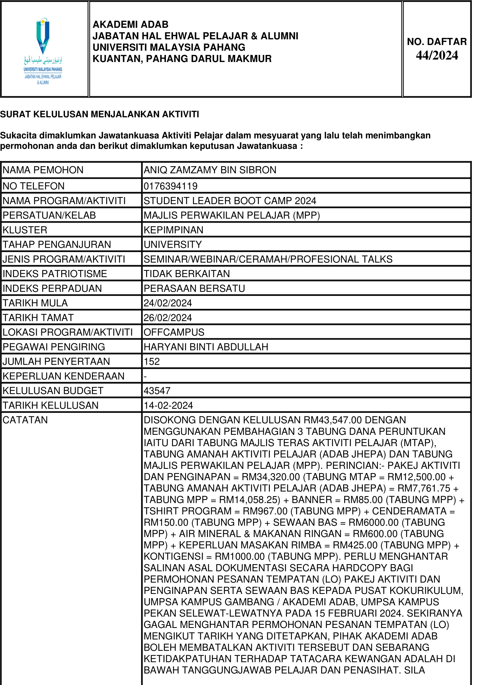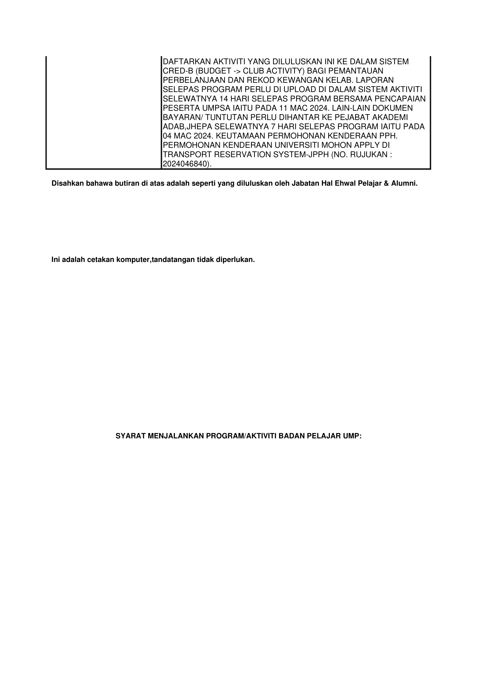

**IMPLIKASI KEWANGAN PROGRAM STUDENT LEADERS BOOT CAMP 2024**

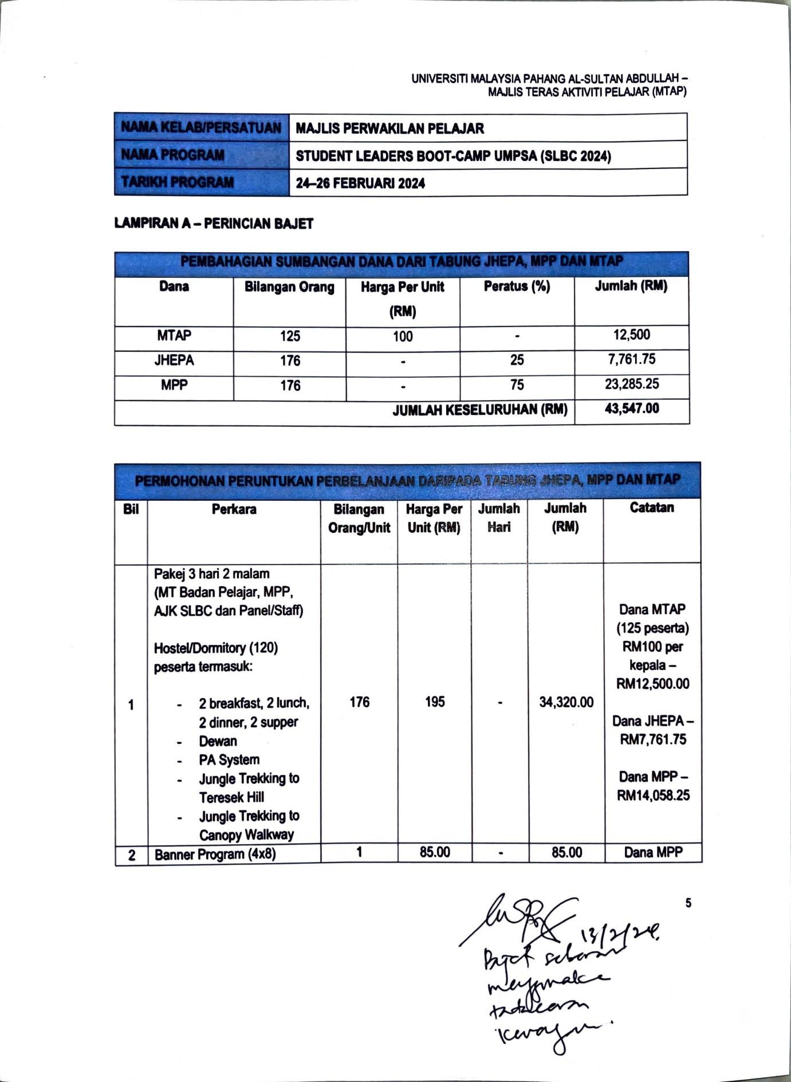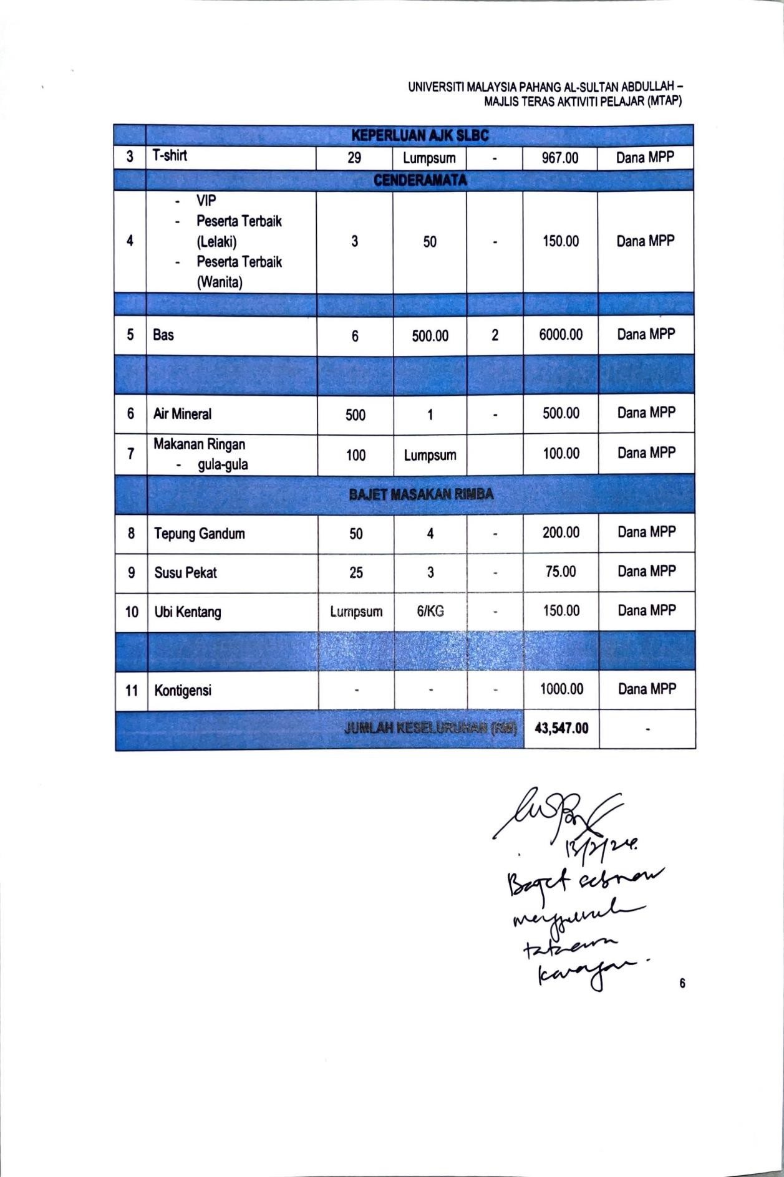

**PENGALIRAN WANG KELUAR MASUK PROGRAM STUDENT LEADERS BOOT CAMP 2024**

|  |  |  |  |  |  |
| --- | --- | --- | --- | --- | --- |
| **WANG MASUK** | | | **WANG KELUAR** | | |
| **BIL** | **CATATAN** | **RM** | **BIL** | **CATATAN** | **RM** |
|  |  |  | 1 | Pakej 3 hari 2 malam  (RM 195 X 176 orang) | 34,320.00 |
| 2 | Banner program (4x8) | 85.00 |
| 3 | T-shirt | 967.00 |
| 4 | Cenderamata VIP, peserta terbaik (lelaki & Perempuan) | 150.00 |
| 5 | Bas | 6000.00 |
| 6 | Air mineral | 500.00 |
| 7 | Makanan ringan (gula-gula) | 100.00 |
| 8 | Masakan rimba | 425.00 |
| 9 | Kontigensi | 1000.00 |
| JUMLAH | | RM 43,547 |
| RM43,547 – RM43,547 = RM 0 | | | | | |

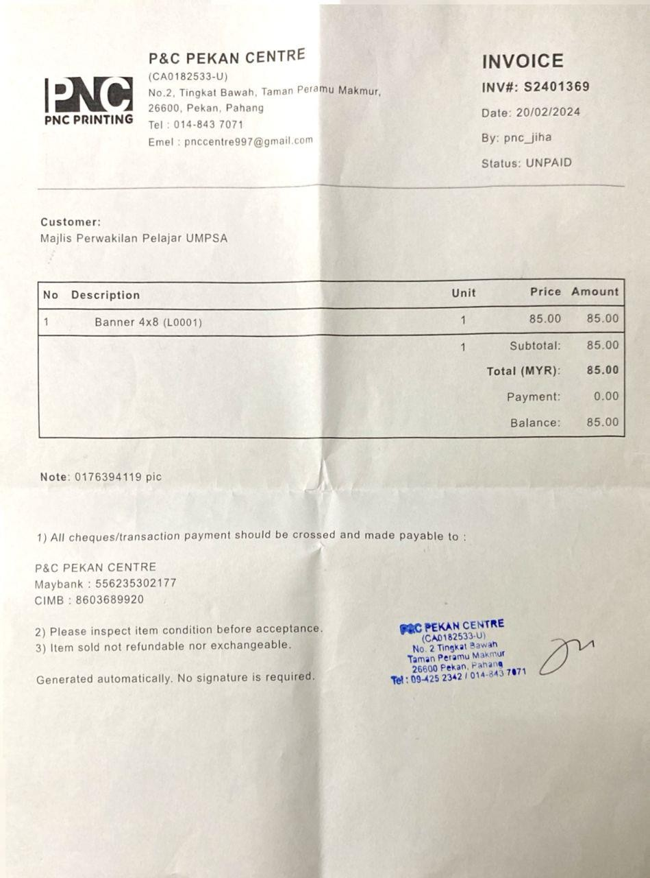

**INVOIS BANNER**

**INVOIS KOPERASI**

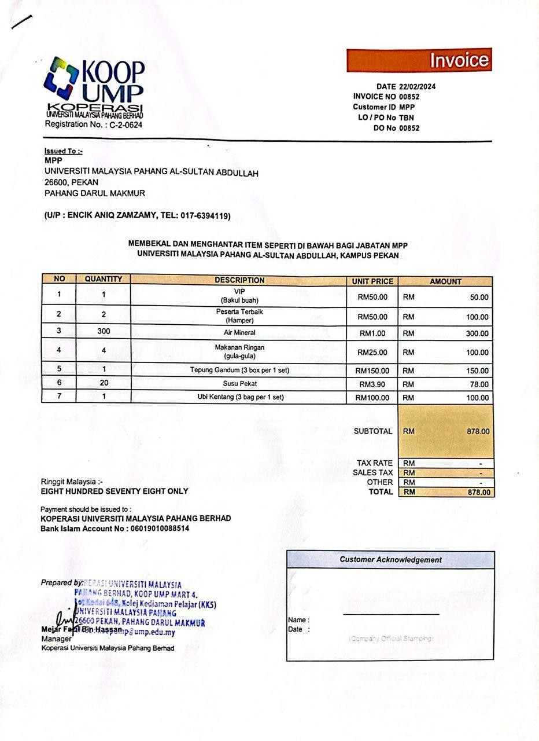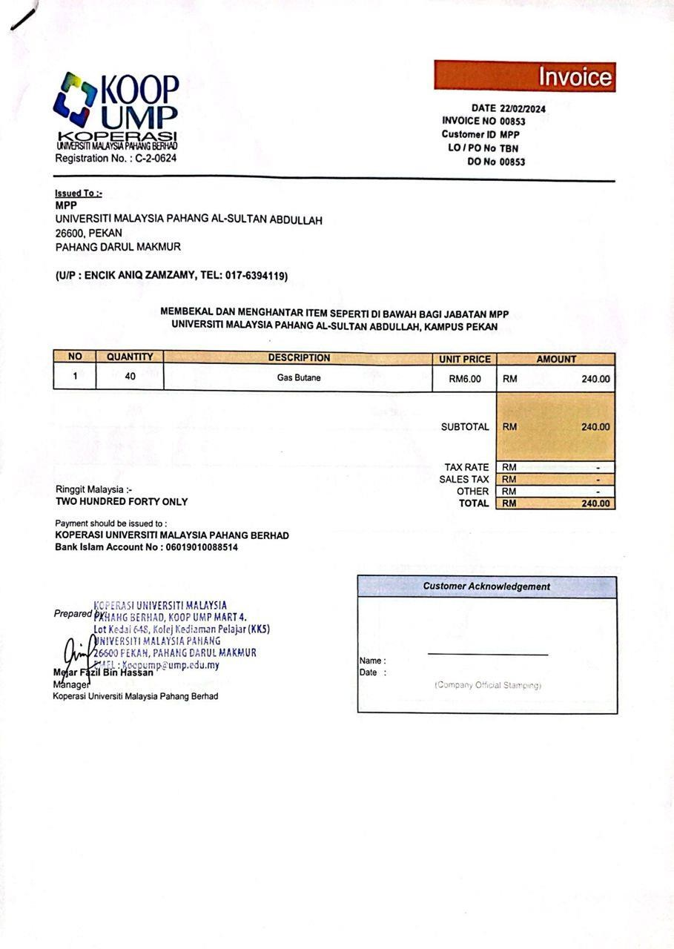

**INVOIS BAJU**

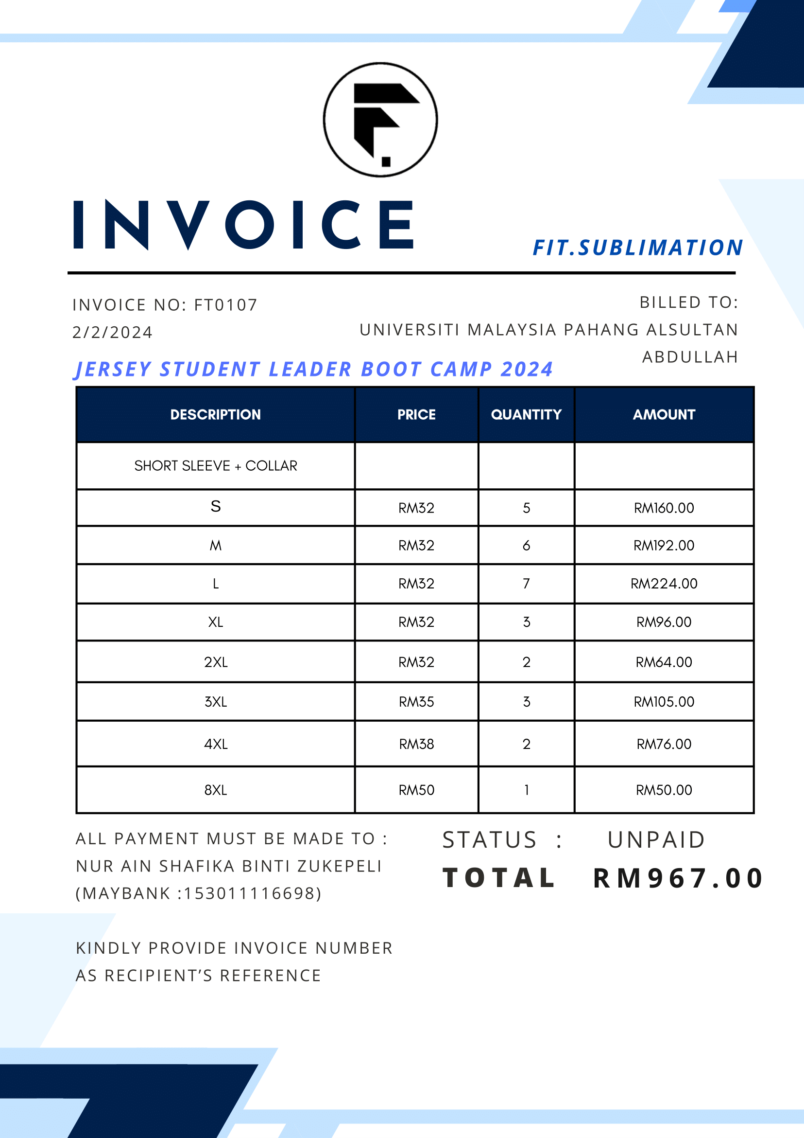

**TENTATIF PROGRAM STUDENT LEADERS BOOT CAMP 2024**

|  |  |  |
| --- | --- | --- |
| **TARIKH** | **MASA** | **AGENDA** |
| 20 Februari 2024  (Selasa) | 08:00 – 10:00am | Taklimat SLBC |
| 24 Februari 2024 (Sabtu) | 07:30 – 12:00pm | Pergerakan peserta ke Taman Negara, Pahang |
| 12:00 – 01:00pm | Short briefing & pendaftaran |
| 01:00 - 02:00pm | Makan tengahari/ rehat/ solat (Jamak) |
| 02:00pm – 02:30pm | Taklimat program |
| 02:30 – 03:30pm | Taklimat Yayasan UMPSA |
| 03:30 – 04:30pm | Proses pelaksanaan aktiviti |
| 04:30 – 05:30pm | Taklimat etika professional |
| 05:30 – 06:30pm | Taklimat tuntutan kredit & aktiviti pelajar |
| 06:30 – 08:30pm | Makan ma;am/ rehat/ solat (Jamak) |
| 08:30 – 10:30pm | Amanat TNC HEPA |
| 10:30 – 11:00pm | Minum malam |
| 25 Februari 2024 (Ahad) | 06:00 – 07:30am | Persiapan kendiri/ solat |
| 07:30 – 08:30am | Sarapan pagi |
| 08:30 – 12:30pm | Aktiviti outdoor jungle trekking & canopy walk |
| 12:30 – 02:30pm | Makan tengahari/ rehat/ solat (Jamak) |

|  |  |  |
| --- | --- | --- |
|  | 02:30 – 03:30pm | Pengurusan kelab & perancangan kelab mengikut teras (dibentangkan oleh wakil MTAP) |
| 03:30 – 04:30pm | Tatacara kewangan |
| 04:30 – 05:30pm | Taklimat system Cred-B (claim credit aktiviti & modul kokurikulum) |
| 05:30 – 06:30pm | Masakan rimba |
| 07:30 – 08:30pm | Makan malam/ rehat/ solat (Jamak) |
| 08:30 – 09:30pm | Pemerkasaan mahasiswa (modul & takwim MTAP) |
| 09:30 – 10:30pm | Sesi soal jawab wakil kelab dengan pihak Akademi ADAB & MTAP |
| 10:30 – 11:00pm | Minum malam |
| 26 Februari 2024 (Isnin) | 06:30 – 07:30am | Persiapan kendiri/ solat subuh |
| 07:30 – 08:30am | Sarapan pagi |
| 08:30 – 10:30am | Bengkel parlimen (perancangan dalam teras usul parlimen & ulasan parlimen mahasiswa sidang 2) |
| 10:30 – 11:30am | Penutupan SLBC |
| 11:30 – 12:00pm | Check out |
| 12:00 – 05:00pm | Tiba di UMPSA |